**CRM TESTING Version 1.5**1.CRM Register page   
  
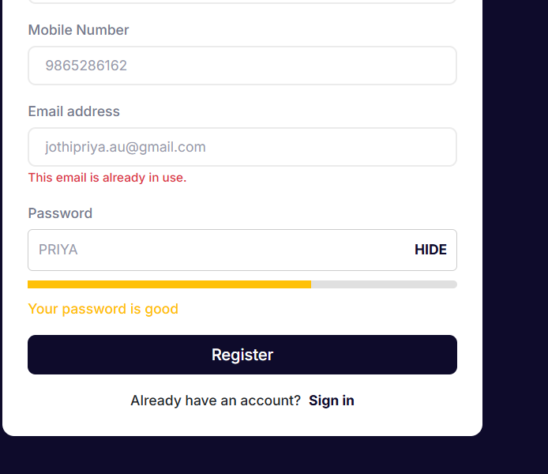  
  
  
While Giving password as 4upper it shows “your password is good”, But it Should not show like that .rectify the cosmetic and validation issue.

2. Login URL Issue   
https://ktnl-test.ktig.info/login/  
While launching to Above URL, Screen should be Displayed like below, But it wrongly displayed.  
  
Correctly displayed Screen   
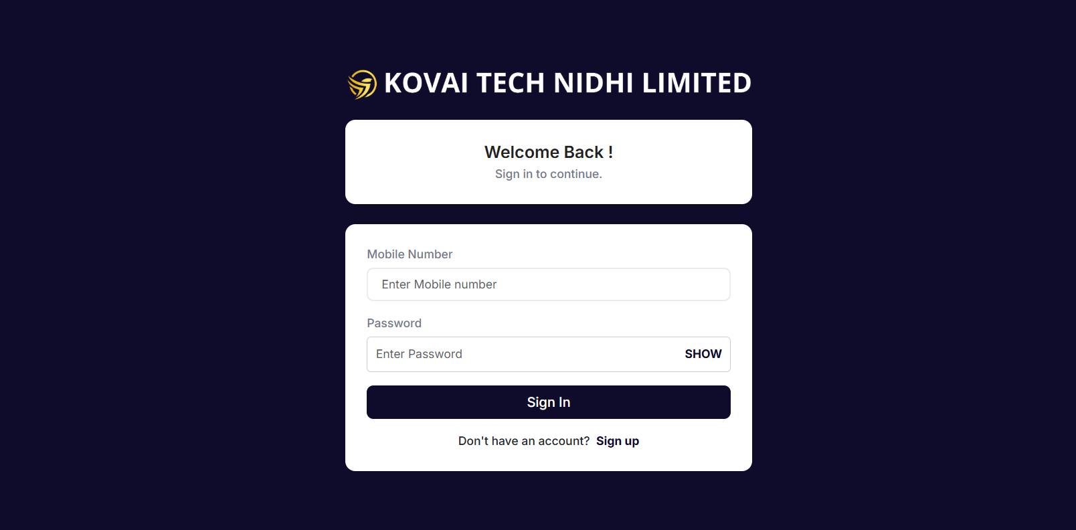  
  
  
Incorrectly displaying Screen   
  
https://ktnl-test.ktig.info/dashboard/  
  
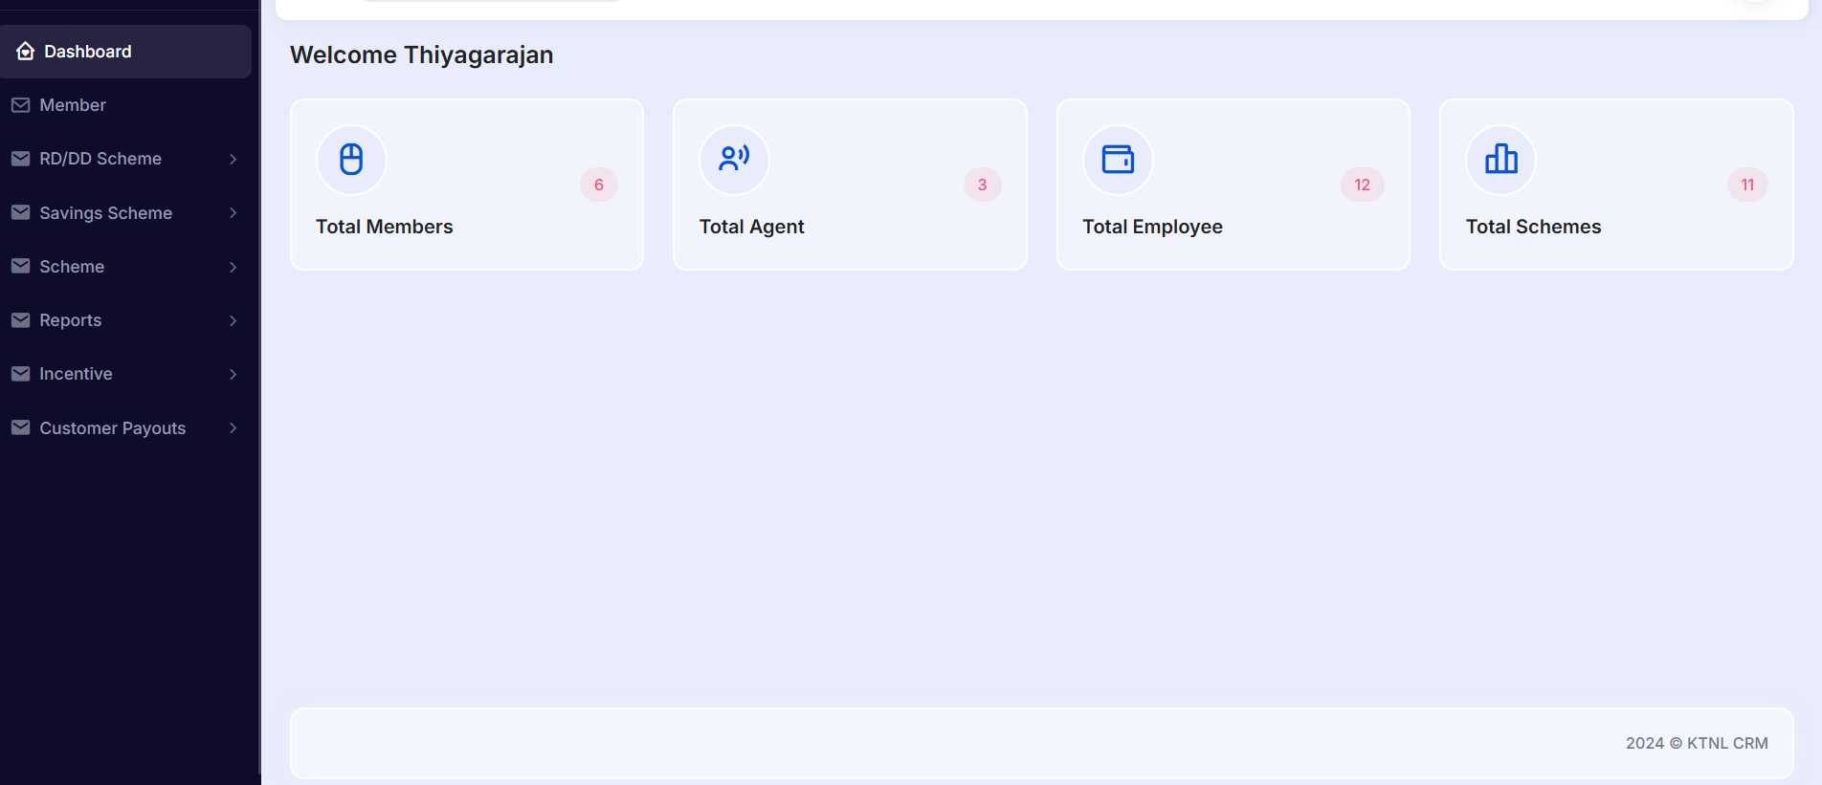

3. CRM – Member   
  
  
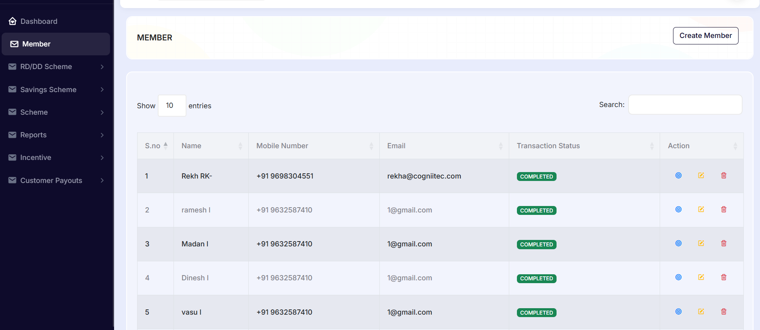  
  
In the member list, only the first member's data can be edited and updated. The data for members 2, 3, 4, 5, and 6 cannot be edited. Fix this to allow editing for all members.